The name of my database is phpworksheet

The name of my table is student

The details in my table are as follows

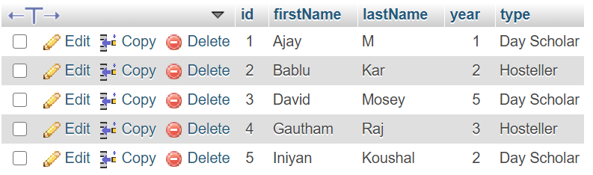

The output of my code was

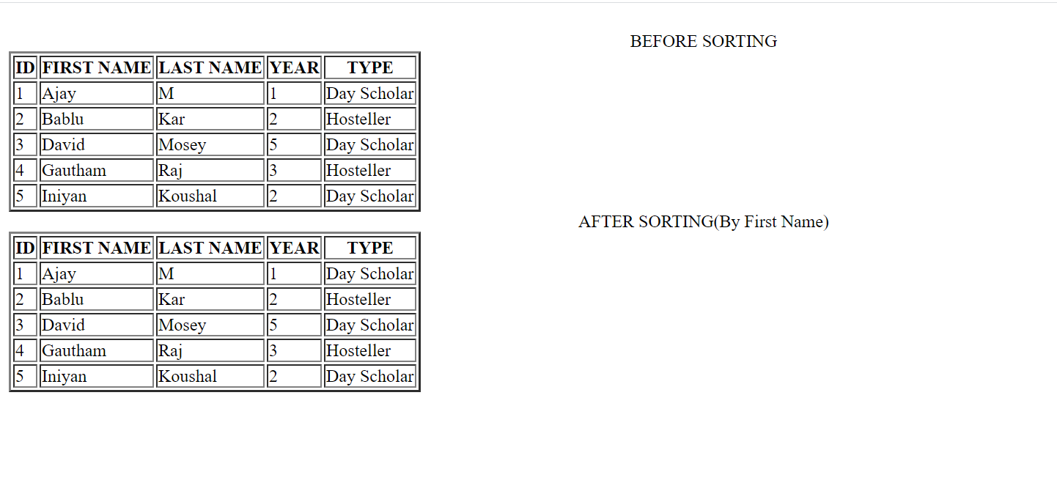

Please include this in your xampp server to get the required output